**Parkinson’s Disease**

**What is Parkinson’s?**

Parkinson’s is a progressive neurodegenerative condition. It is caused by insufficient quantities of dopamine - a chemical in the brain. Dopamine enables quick, well-coordinated movement. When dopamine levels fall, movements become slow and awkward. Parkinson’s has both motor and non-motor symptoms, and while it cannot be cured it can be treated.

As Parkinson’s is a progressive condition, it can often take many years to develop and has little effect on life expectancy. Different people will experience a different number and combination of symptoms.

Parkinson's is part of an umbrella of conditions known as ‘parkinsonism’. The main symptoms of Parkinson's are also the main symptoms of a number of conditions which are grouped together under the term 'parkinsonism'.

Parkinson's is sometimes referred to as idiopathic Parkinson's disease. This is because the majority of people with Parkinson’s do not know what caused it.

** this disease not only causes resting tremors but also affects different cognitive aspects: attention and memory problems, visuospatial alterations, slow processing, executive and language dysfunction. Parkinson's is associated with delays and difficulties in functional, work and social functioning.

Tremor is defined as an involuntary trembling of a body part. There are three main types of tremor:

-       Resting tremor

-       Action (Kinetic) tremor

-       Postural tremor

All of these types of tremor can be seen in Parkinson’s disease, even though resting tremor is the more frequently observed one and also the most severe when all three tremors are present in PD.

Not only do people with Parkinson's have motor tremors and difficulties, but the brain alterations resulting from the disease also have negative cognitive consequences. The brain areas that are mainly altered in Parkinson's disease are the Substantia Nigra and, consequently, the Basal Ganglia.

|  |  |
| --- | --- |
| 1. Substantia Nigra   Substantia Nigra or black substance is a set of dopaminergic neurons (which produce the neurotransmitter "dopamine") pigmented by an element called "neuromelanin", which gives it a blackish color. The dopaminergic axons of these neurons connect with other nuclei of the basal ganglia. In Parkinson's disease ,the neurons of the black substance are destroyed, which disrupts or makes it difficult to connect dopamine between the black substance and the basal ganglia. | C:\Users\aceos\OneDrive\Pictures\Screenshots\Screenshot (38).png |
| 1. Basal Ganglia     Basal ganglia are a set of subcortical structures located at the "base" of the brain. The main function of the basal ganglia is to regulate voluntary movement and to learn motor skills. Dopamine is a fundamental neurotransmitter in the correct functioning of the basal ganglia. With the death of dopaminergic neurons of the black substance, basal ganglia act erratically, producing Parkinson's symptoms such as the stiffness and slowness of movement, in addition to certain cognitive symptoms. |

it is very important to focus on observing the patients while they are giving the history, to notice any motor disturbances present at rest.

In particular we should focus on:

-       Spontaneous movements, generally reduced in PD

-       Hands gestures while talking, usually reduced or absent

-       Eyeblink, whose spontaneous rate is reduced

-       Resting tremor, usually affecting one hand only

-       Fidgeting and crossing/uncrossing of the legs, that may indicate dyskinesia, a complication of chronic Levodopa therapy

** Exercise is vital for people with Parkinson's.

Along with circuit training exercises for strength and flexibility, there are specific types of exercises that research indicates may slow down the progression of Parkinson's.

People with Parkinson's should attempt to get at least 20 to 30 minutes of exercise each day.

**What causes Parkinson’s?**

Although we know a lot about the changes in the nerve cells of the brain in Parkinson’s, we do not yet know what causes or triggers the development of Parkinson’s. Symptoms can be treated but there is no known cure. Researchers across the world continue to investigate new treatments.

Parkinson’s is often referred to as ‘Parkinson’s disease’ but it is not contagious and you cannot pass it from one person to another.

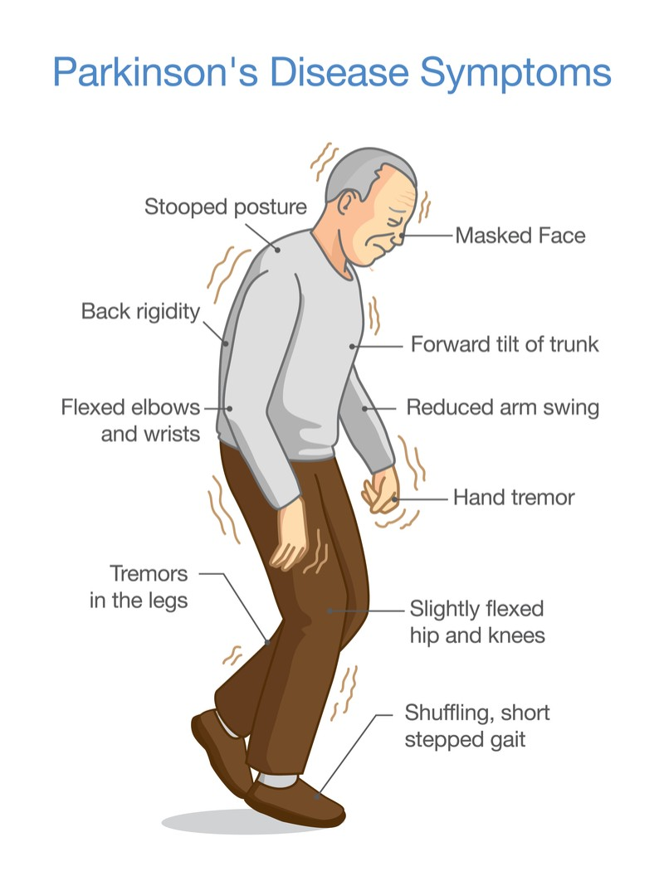

**Parkinson's disease tests**

* **Finger Tapping Test :**

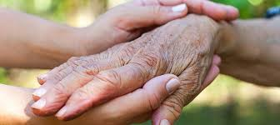

Bradykinesia relates to the slowness of movement, and it is a core clinical sign of Parkinson’s disease (PD). Finger tapping tests have been widely utilized in neurophysiological examinations to assess upper extremity bradykinesia. Finger tapping is assessed , using the gold standard Movement Disorder Society Unified Parkinson’s Disease Rating Scale (MDS-UPDRS)2. Although the MDS-UPDRS-III is a comprehensive assessment, the integer scale prevents detection of subtle motor changes3,4 and inter-rater agreement is moderate at best5. Hence, a clear need for objective and consistent methods of assessing motor dysfunction exists.

In finger tapping the patient is instructed to tap the index finger on the thumb as fast possible and as big as possible. This means that the patient should try to separate the two fingers as much as possible before tapping them. Make sure to test both the right and the left side.

finger Tapping (DFT) test was developed to assess distal upper-limb function .

The DFT and BRAIN tests were assessed in 55 PD patients and 65 controls. Test scores were compared between groups and correlated with the MDS-UPDRS-III finger tapping sub-scores. Nine additional PD patients were recruited for monitoring motor fluctuations.

A combination of DFT and BRAIN tests improved discrimination (AUC = 0.95).

the DFT test detected subtle changes in motor fluctuation states which were not reflected clearly by the MDS-UPDRS-III finger tapping sub-scores.

**The DFT test is a tool for assessing distal movements in PD, with future scope for longitudinal monitoring of motor complications.**

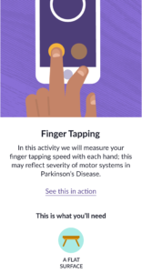

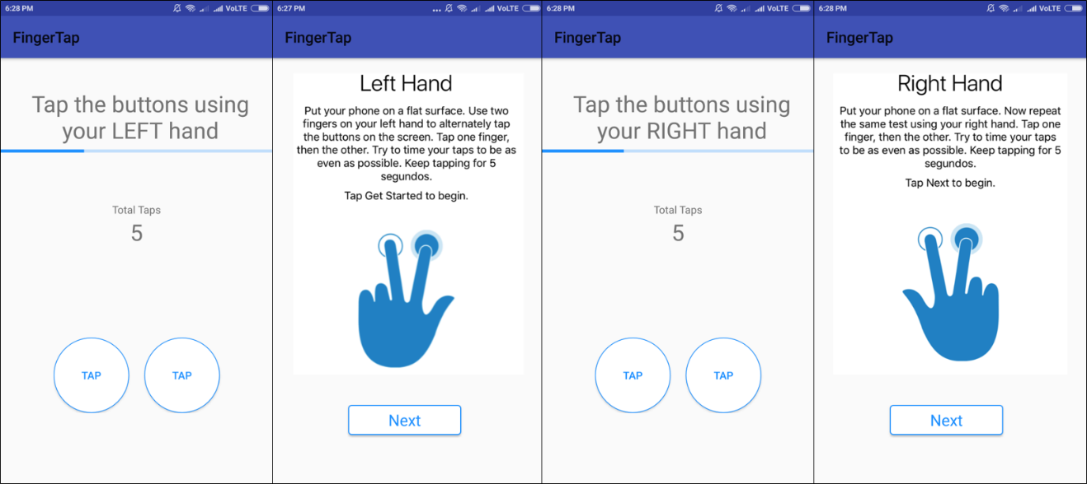

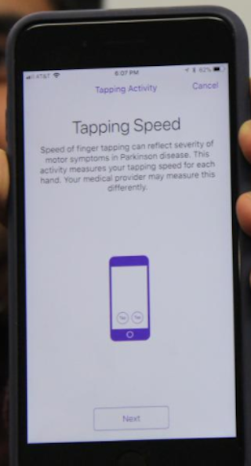

* **Memory Test :**

People suffering from Parkinson's disease (PD), in addition to the most characteristic symptoms of the disease, such as tremors or slowness of movement, are at risk of suffering cognitive disturbances that affect their daily life. It is not uncommon to observe an impairment in processing speed, attention, memory or response time, among other cognitive alterations.

So Memory test is a test to detect cognitive impairment related to Parkinson's Disease. Performs a complete cognitive screening and assesses the risk index of Parkinson's disease.

The goal of this test is to prevent and stop symptoms and cognitive impairment , whether mild, moderate or severe and to improve the cognitive functioning of people affected by Parkinson's disease. helps prevent cognitive-related functional impairment and improves quality of life.

## **Paired Associates Learning**

**What does this task measure?**  
PAL measures visual memory and new learning, and is a sensitive tool for accurate assessment of episodic memory.

**What does this task involve?**  
Six boxes are presented on the screen, which open one by one in a randomized order to reveal patterns hidden inside. The patterns are then displayed in the middle of the screen, one at a time, and the subject must touch the box where the pattern was originally located. If the subject makes an error, the patterns are re-presented to remind the subject of their locations. The task becomes progressively more difficult, starting from a two pattern stage, to a four pattern, a six pattern and an eight pattern stage. If a participant continues to make errors on the fourth attempt at any stage, the task with automatically terminate due to the understanding that there is significant cognitive impairment and are unable to identify.

Test idea : <https://youtu.be/6yaw0ZtFBz0>

**Why use this task?**  
PAL is an interactive tool to evaluate episodic memory, which is often impaired in the early stages of Parkinson’s disease5. Tasks such as this which hone in on the recall of patients helps establish the link etween dementia and Parkinson’s; how the retrogression of the memory and messages decay within the substania nigra which leads to dementia within 50%+ of patients3.

**[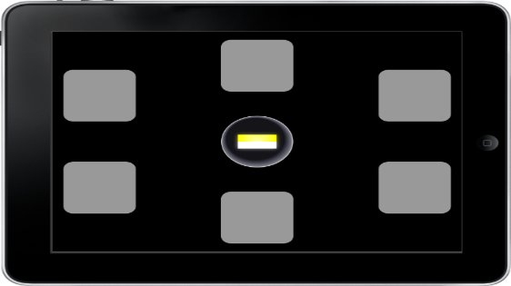](https://www.cambridgecognition.com/cantab/cognitive-tests/memory/paired-associates-learning-pal)**

## **Reaction Time :**

**What does this task measure?**  
RTI provides assays of motor and mental response speeds, as well as measures of movement time, reaction time and response accuracy.  
  
**What does this task involve?**  
In this reaction time task the subject must hold down a virtual button at the bottom of the screen. A yellow spot will momentarily appear inside one of five yellow circles at the top of the screen. Subjects must respond to the spot as quickly as they can by letting go of the button and touching the circle where the yellow spot appeared and if missed or too slow, it becomes incorrect. This is repeated for 30 trials. Practice trials are initially available to familiarise subjects with the task. RTI provides 11 outcome measures, including reaction times, movement times, and error scores.  
  
**Why use this task?**

Within Parkinson’s disease, the neurotransmitters slow and decay leading to slower processing of information, resulting in increase of reaction time. Through trials done using this task, when compared to other illnesses and problems caused such as Alzheimer’s, cognitive impairment and weakened working memory, Parkinson’s suffered the poorest reaction times17. This can come down to the issue that many suffer from a late diagnosis.

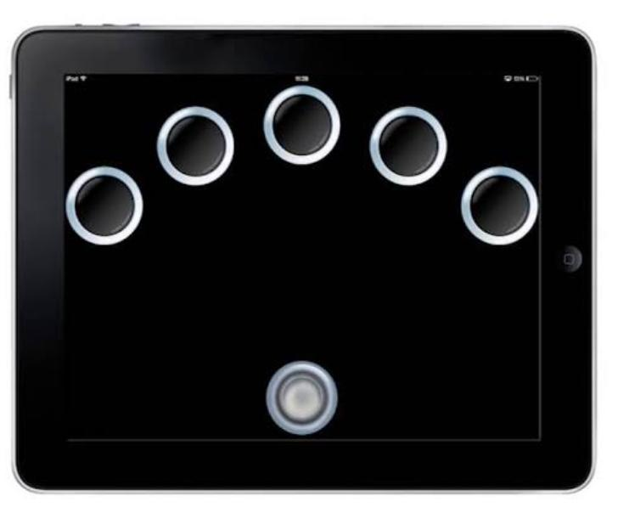 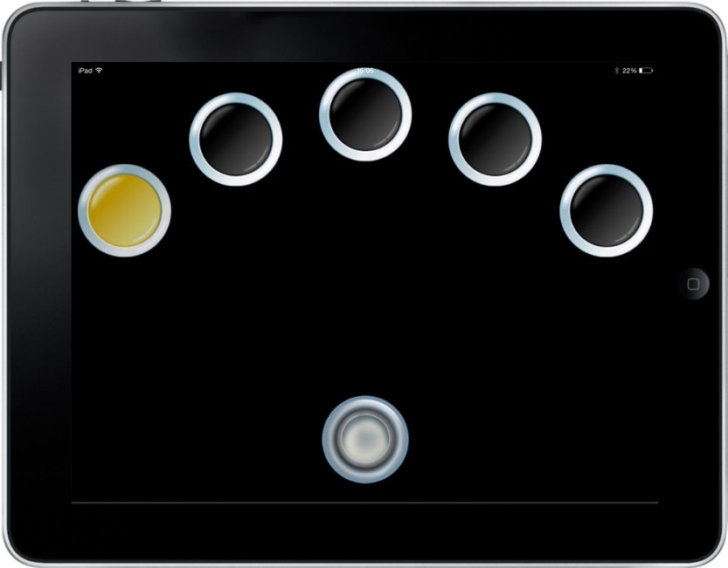

* **Spiral Test :**

Spiral drawing has been utilized for years as a clinical tool to observe tremors and other abnormal movements in the assessment of different movement disorders. Specifically, in Parkinson's Disease (PD), patients' motor functionalities are measured by various tests, and spiral drawing is one of the proven techniques for assessing the severity of PD motor symptoms. Traditionally, this test is performed on pen and paper, and visually assessed by a clinician. There have been successful efforts for digitizing this test on tablets. Here, we describe a smartphone-based digitized version of the spiral drawing test. approache are evaluated with 8 Parkinson's Disease patients and 6 age-matching control participants. Based on earlier studies and our data, we select suitable motion parameters for quantifying the task. Our results show an observable, statistically difference in performance between users with Parkinson's Disease and the control group in drawing accuracy.

Spiral test is a type of intelligence assessment in which the focused themes being evaluated are distributed throughout the test, instead of being grouped together, and become increasingly difficult as the test progresses. Each subsequent spiral of difficulty covers a different domain of intelligence

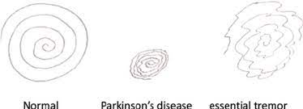

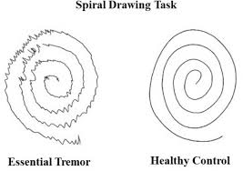

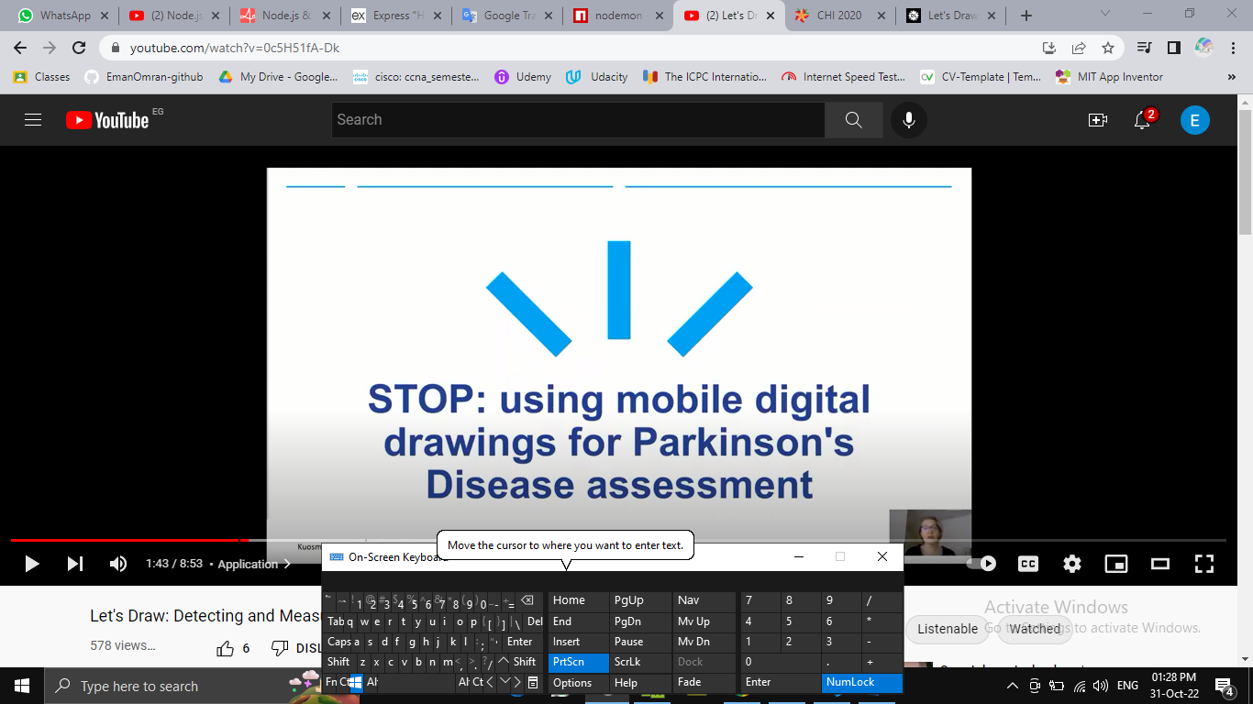

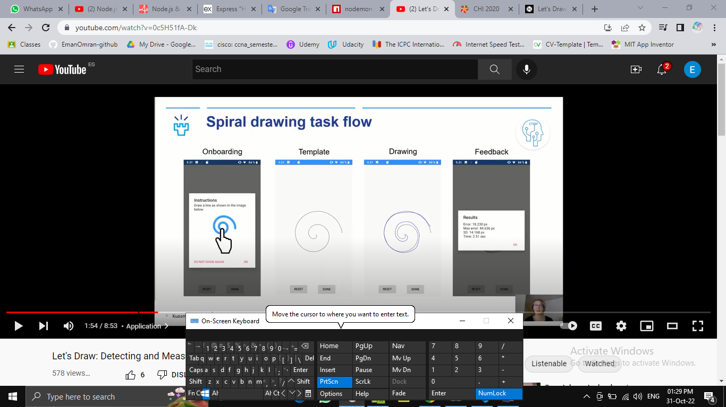

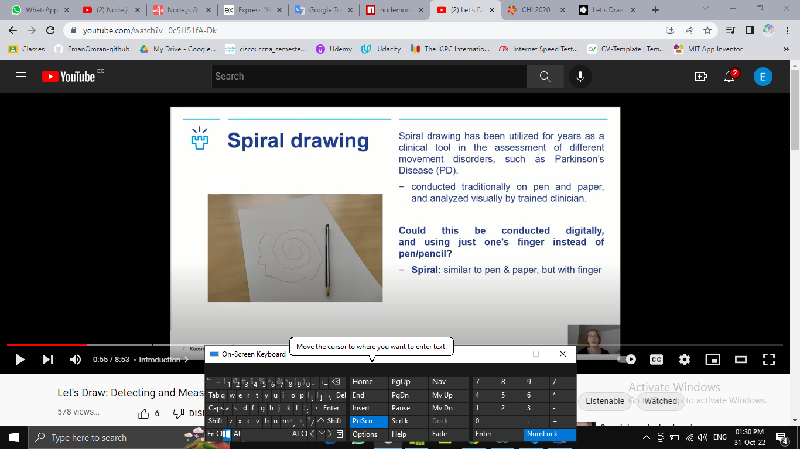

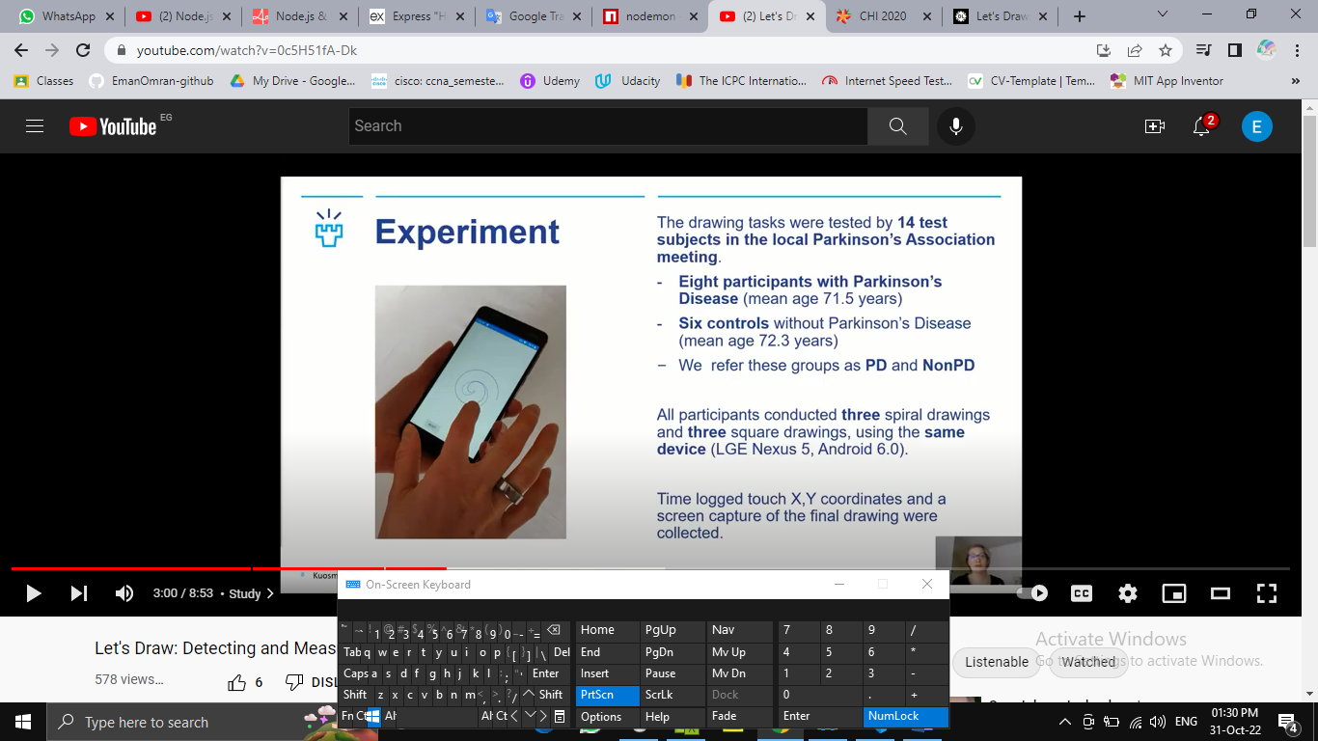

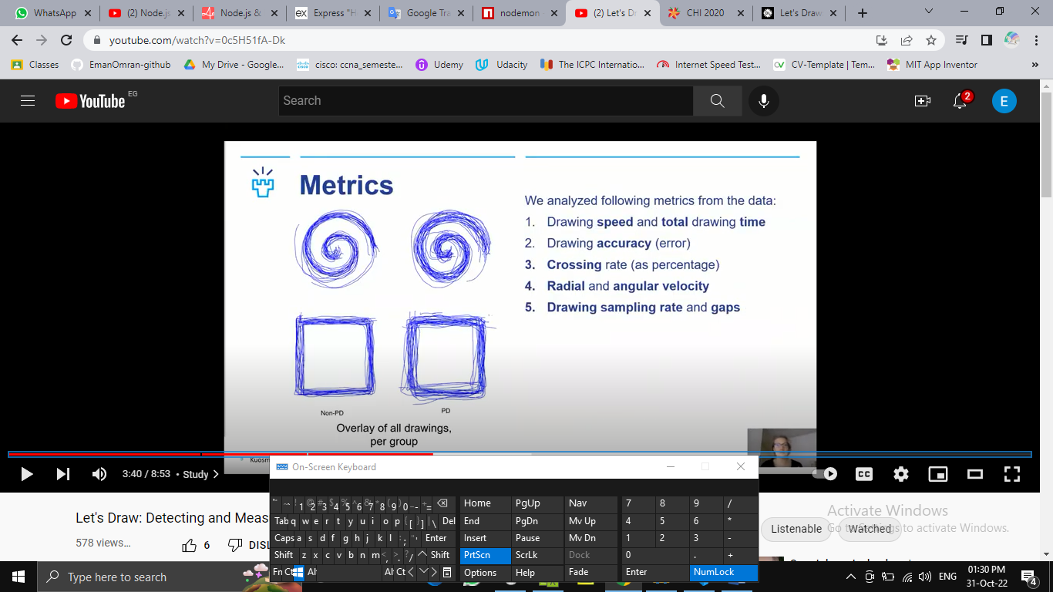 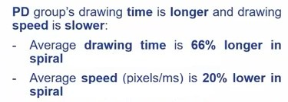

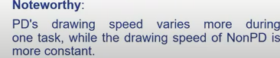

* **Speech Test :**

Parkinson's disease (PD) is characterized by specific voice disorders collectively termed hypokinetic dysarthria. We here investigated voice changes by using machine learning algorithms, in a large cohort of patients with PD in different stages of the disease

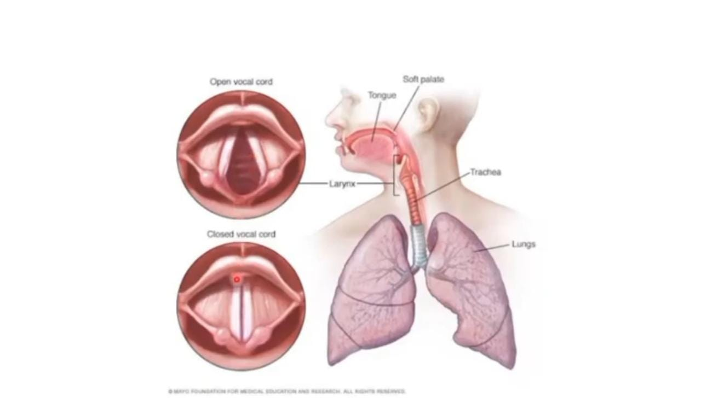

Speech:difficulty of speaking, soft speech, or voice box spasms,breathly voice,slur or monotone voice

**needs for speech recognition:**

1. device to record clear speech signal
2. speech features dataset
3. A numerical computing software

**symptoms include:**

1. Lower volume and rhythm
2. soft or hoarse tune
3. stuttering

**\*\*** the data set will include the recording values of **vowels like a e i o u and ‘ahhhhh’** word.

The patient must test his voice by saying one of these things using the recorder in the test.

the result ill be the accuracy of thesound’s frequency as percentage.

 

**Parkinson’s Exercises**

Exercise is an important part of healthy living for everyone. For those with Parkinson’s disease (PD), exercise is more than healthy — it is a vital component to maintaining balance, mobility and activities of daily living. Research shows that exercise and physical activity can not only maintain and improve mobility, flexibility and balance but also ease non-motor PD symptoms such as depression or constipation.

The Parkinson’s Outcomes Project shows that people with PD who start exercising earlier in their disease course for a minimum of 2.5 hours per week experience a slowed decline in quality of life compared to those who start later. Establishing early exercise habits is essential to overall disease management.

What type of exercise should I do?

To help manage the symptoms of PD, your exercise program should include these key components:

1. Aerobic Activity
2. Strength Training
3. Balance, Agility & Multitasking
4. Flexibility

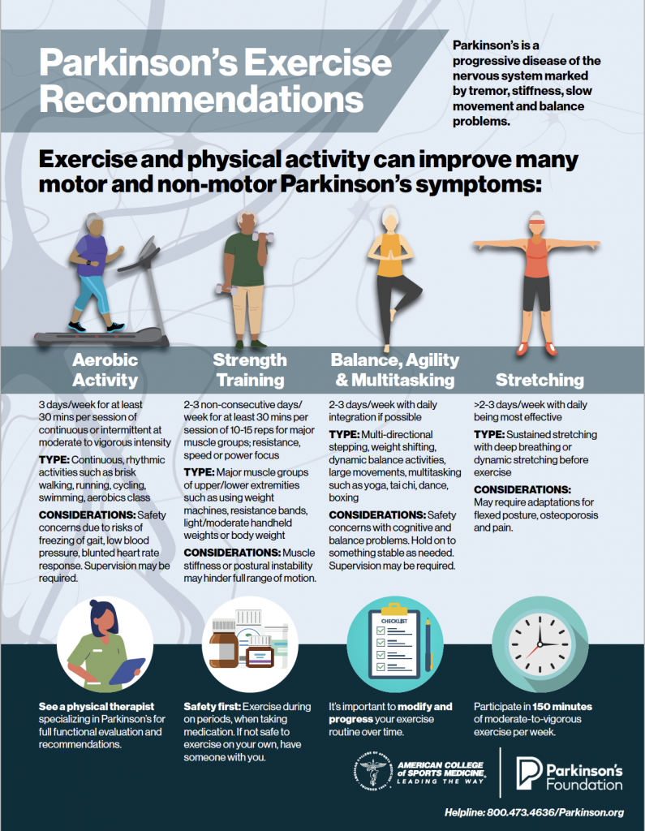

What kind of exercise can I do if I have trouble standing or walking?

Even with advanced Parkinson’s symptoms, you can still reap the benefits of some activities. If you have trouble walking or balancing, hold a bar or rail to exercise and stretch. If standing or getting up is tough, exercise and stretch in a chair or bed. Physical exercise performed in a seated position, such as biking on a recumbent bike (bike with a seat and back support) can allow you to exert yourself in a safe manner.

Aerobic exercise:

<https://youtu.be/h9NQc0LYrwE>

Strength training:

[<https://youtu.be/Gh8cZ_W2vR4>](https://youtu.be/uOljoOvycuo)

Flexibility training:

[<https://youtu.be/mzmNrHRusxw>](https://youtu.be/uOljoOvycuo)

Balance and agility training:

[<https://youtu.be/uOljoOvycuo>](https://youtu.be/uOljoOvycuo)

Dance training:

<https://youtu.be/pamOsmXyA38>

Hand Exercises:

<https://youtu.be/Ez2GeaMa4c8>

Swallowing Mouth and Tongue Exercises:

<https://youtu.be/78ubEwgZL20>